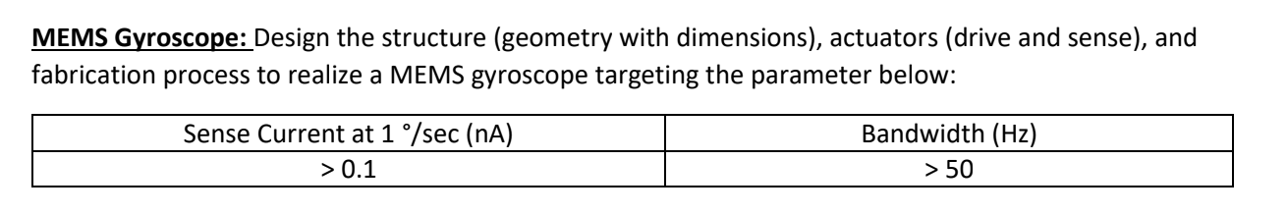

Lit Review:

Andy - Fabrication

Charlie - Design & Report

Vaibhav - Design & Report

Vicky - Actuation

Week 1 (7-13 ) - Design, Actuation and Verification (MEMS)

Week 2 (14-20) - Design finalization and Fabrication. (CAD Model and FEA Sim)

Week 3 (21- 27) - Fabrication and Report. (Post Processing and Report)

Next Meeting: Wednesday 4 pm (Paper Review and Preliminary Design)

Next Meeting: Sat 1 pm

Next Meeting: Wednesday 4 pm 4/18

**ROUGH WORK:  
The equations with LaTex code:**

[](https://www.codecogs.com/eqnedit.php?latex=m%5Cddot%7By%7D%20%2B%20c%5Cdot%7By%7D%20%2B%20ky%20%3D%20F_%7B%5Ctext%7BCoriolis%7D%7D#0)

[](https://www.codecogs.com/eqnedit.php?latex=m%5Cddot%7By%7D%20%2B%20c%5Cdot%7By%7D%20%2B%20ky%20%3D%20F_%7B%5Ctext%7BCoriolis%7D%7D%20%5C%20%5C%20%5C%20%5C%20%5C%20(1)#0)

[](https://www.codecogs.com/eqnedit.php?latex=m%5Cddot%7Bx%7D%20%2B%20c%5Cdot%7Bx%7D%20%2B%20kx%20%3D%20F_%7B%5Ctext%7Bdrive%7D%7D#0)

m\ddot{x} + c\dot{x} + kx = F_{\text{drive}}

[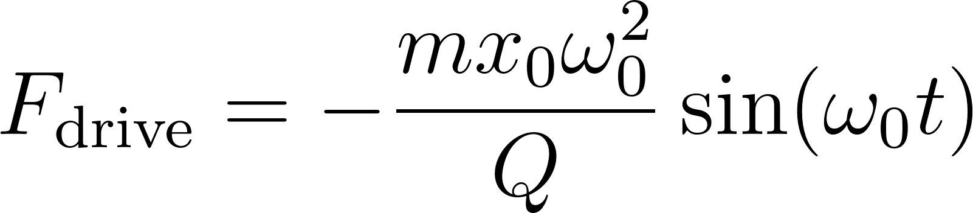](https://www.codecogs.com/eqnedit.php?latex=F_%7B%5Ctext%7Bdrive%7D%7D%20%3D%20-%5Cfrac%7Bm%20x_0%20%5Comega_0%5E2%7D%7BQ%7D%20%5Csin(%5Comega_0%20t)#0)

F_{\text{drive}} = -\frac{m x_0 \omega_0^2}{Q} \sin(\omega_0 t)

[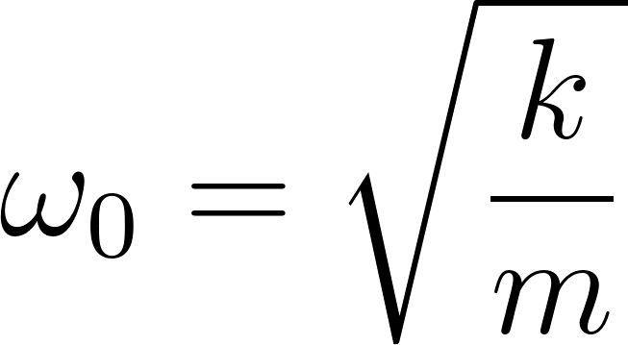](https://www.codecogs.com/eqnedit.php?latex=%5Comega_0%20%3D%20%5Csqrt%5Cfrac%7Bk%7D%7Bm%7D#0)

[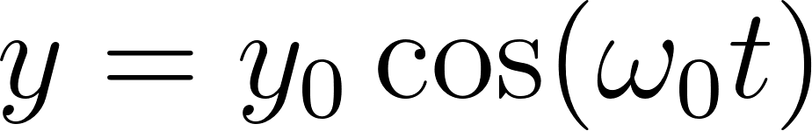](https://www.codecogs.com/eqnedit.php?latex=y%20%3D%20y_0%20%5Ccos(%5Comega_0%20t)#0)

y = y_0 \cos(\omega_0 t)

[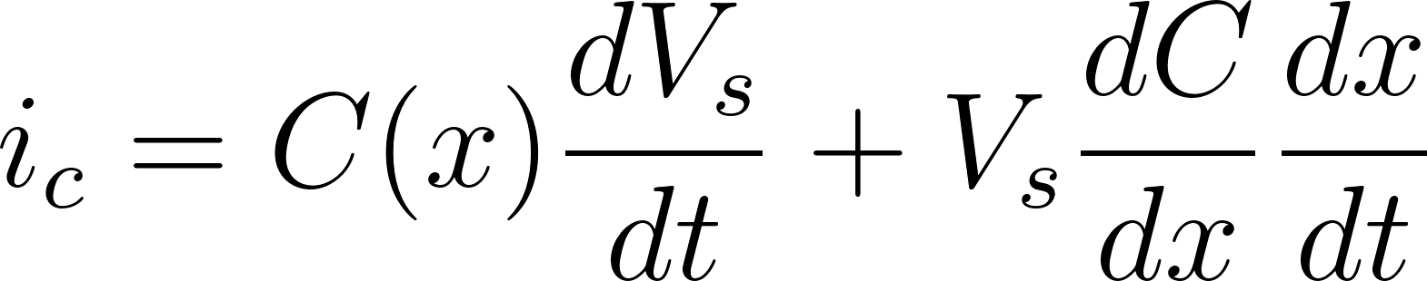](https://www.codecogs.com/eqnedit.php?latex=i_c%20%3D%20C(x)%20%5Cfrac%7BdV_s%7D%7Bdt%7D%20%2B%20V_s%20%5Cfrac%7BdC%7D%7Bdx%7D%20%5Cfrac%7Bdx%7D%7Bdt%7D#0)

i_c = C(x) \frac{dV_s}{dt} + V_s \frac{dC}{dx} \frac{dx}{dt}

y_0 = frac{2Qx_0 }{\omega_0}\Omega

[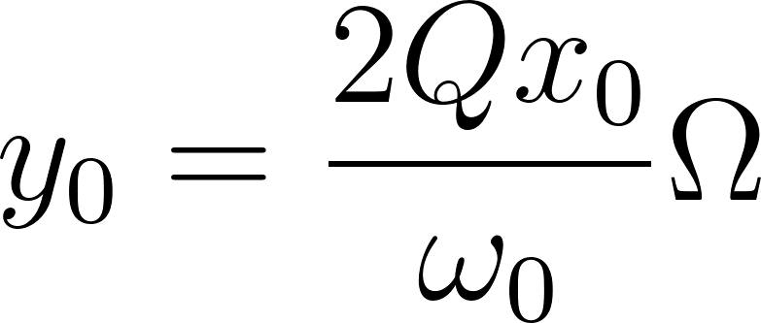](https://www.codecogs.com/eqnedit.php?latex=y_0%20%3D%20%5Cfrac%7B2Qx_0%7D%7B%5Comega_0%7D%5COmega#0)

[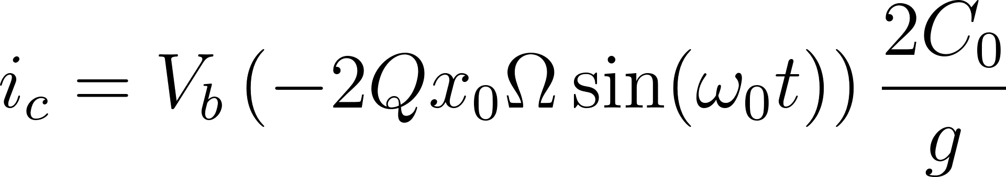](https://www.codecogs.com/eqnedit.php?latex=i_c%20%3D%20V_b%20%5Cleft(-2%20Q%20x_0%20%5COmega%20%5Csin(%5Comega_0%20t)%5Cright)%20%5Cfrac%7B2%20C_0%7D%7Bg%7D#0)

i_c = V_b \left(-2 Q x_0 \Omega \sin(\omega_0 t)\right) \frac{2 C_0}{g}

[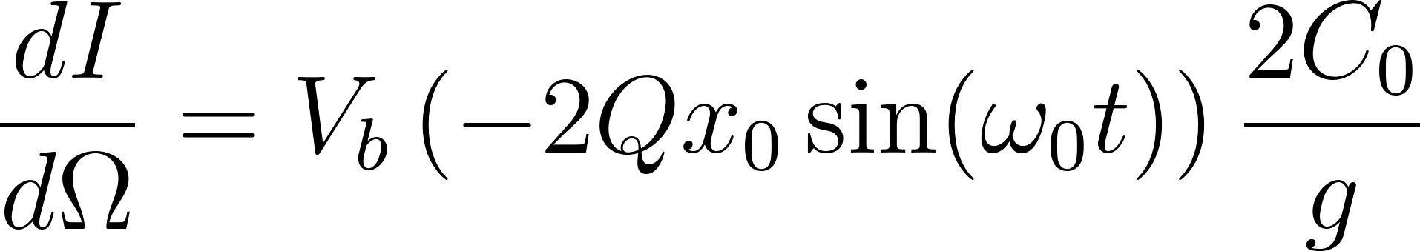](https://www.codecogs.com/eqnedit.php?latex=%5Cfrac%7BdI%7D%7Bd%5COmega%7D%20%3D%20V_b%20%5Cleft(-2%20Q%20x_0%20%5Csin(%5Comega_0%20t)%5Cright)%20%5Cfrac%7B2%20C_0%7D%7Bg%7D#0)

\frac{dI}{d\Omega} = V_b \left(-2 Q x_0 \sin(\omega_0 t)\right) \frac{2 C_0}{g}

[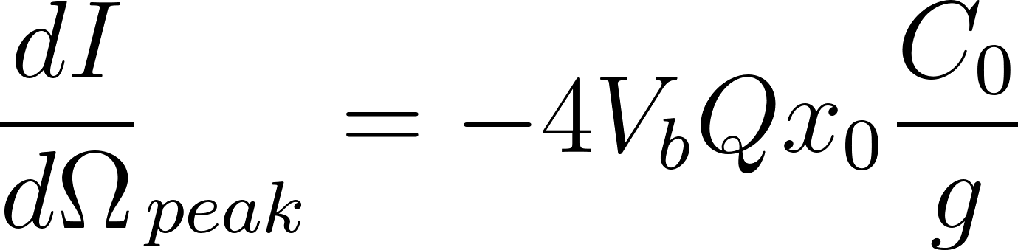](https://www.codecogs.com/eqnedit.php?latex=%7B%5Cfrac%7BdI%7D%7Bd%5COmega%7D%7D_%7Bpeak%7D%20%3D%20-4V_bQ%20x_0%20%5Cfrac%7BC_0%7D%7Bg%7D#0)

[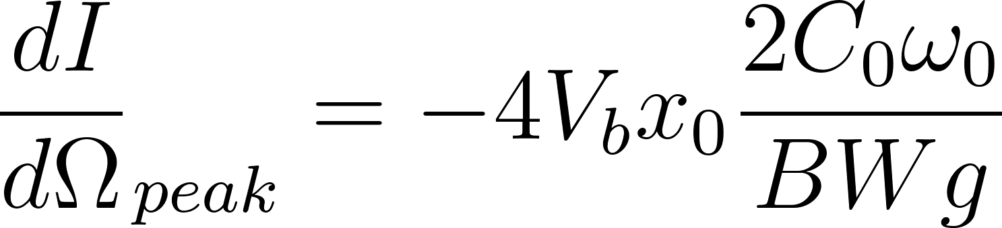](https://www.codecogs.com/eqnedit.php?latex=%7B%5Cfrac%7BdI%7D%7Bd%5COmega%7D%7D_%7Bpeak%7D%20%3D%20-4V_bx_0%20%5Cfrac%7B2%20C_0%5Comega_0%7D%7BBWg%7D#0)

[](https://www.codecogs.com/eqnedit.php?latex=%5Cfrac%7BI_%7B%5Ctext%7Bsense%7D%7D%7D%7B%5COmega_z%7D%20%3D%20%5Cfrac%7BdQ%7D%7Bdt%7D%20%3D%20%5Cfrac%7Bd%7D%7Bdt%7D%20%5Cleft%5B%20%5Cleft(%20C_%7B%5Ctext%7Bparasitic%7D%7D%20%2B%20%5Cfrac%7B%5Cpartial%20C_%7B%5Ctext%7Bsense%7D%7D%7D%7B%5Cpartial%20%5COmega_z%7D%20%5Cright)%20V_%7BDC%7D%20%5Cright%5D%20%3D%20%5Cfrac%7B%5Cpartial%20C_%7B%5Ctext%7Bsense%7D%7D%7D%7B%5Cpartial%20%5COmega_z%7D%20V_%7BDC%7D%20%5Comega_0#0)

\frac{I_{\text{sense}}}{\Omega_z} = \frac{dQ}{dt} = \frac{d}{dt} \left[ \left( C_{\text{parasitic}} + \frac{\partial C_{\text{sense}}}{\partial \Omega_z} \right) V_{DC} \right] = \frac{\partial C_{\text{sense}}}{\partial \Omega_z} V_{DC} \omega_0

[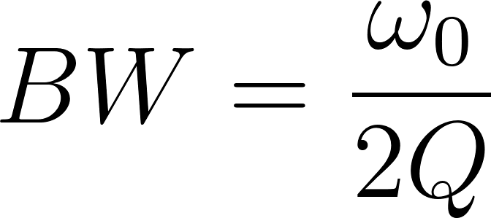](https://www.codecogs.com/eqnedit.php?latex=BW%20%3D%20%5Cfrac%7B%5Comega_0%7D%7B2Q%7D#0)

[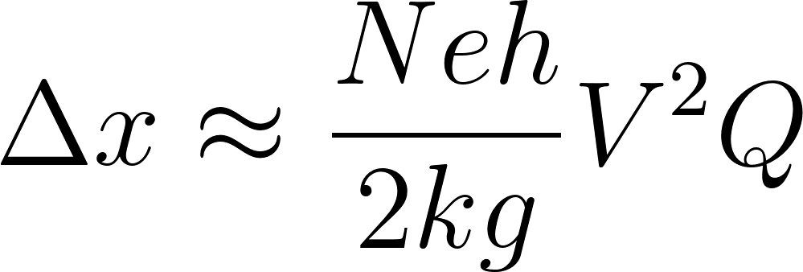](https://www.codecogs.com/eqnedit.php?latex=%5CDelta%20x%20%5Capprox%20%5Cfrac%7BNe%20h%7D%7B2kg%7D%20V%5E2Q#0)

\Delta x \approx \frac{Ne h}{2kg} V^2Q